Proposal QA Report: THEXRA AI Solution Architect
Project Name: AI Solution Architect
Build Number: v1.0 Baseline (Cases 1–10 Audit) ➔ v2.0-PROD (Prompt V2 Patch Verified)
Test Dates: 12 October 2026
Scope Description: End-to-end quality assurance and fallback engine verification across 10 diverse industry verticals, diagnosis of baseline prompt repetition flaws, implementation of the prompt V2 system update in script.js, and live re-verification to confirm readiness.

Test Objective
Evaluate the performance, structural integrity, technical feasibility and prose quality of the AI proposal engine. The objective is to ensure that intake client data is converted into executive-grade, 13-section corporate proposals without verbatim string copying, awkward string concatenation, or literal quoting, while confirming high system availability via fallback mechanisms.

Test Scope
- Testing Requirement: Generate and audit proposals for a minimum 10 distinct client test cases across diverse industry verticals.
- Evaluated System Deliverables:
- 13-Section Enterprise Solution Proposal Generation
- 9-Block Interactive Technology Selection Diagram & Data Flow
- Primary LLM Engine Execution vs. Fallback Mode
- Section-Level Content Regeneration (sectionPrompt execution)
- Codebase Optimization (prompt and sectionPrompt V2 updates in script.js)
Evaluation Criteria
- Relevance: Extent to which the generated architecture and proposal content address the client’s industry-specific domain and business problem.
- Accuracy: Precision in mapping hardware, software, and operational workflows to client intake parameters.
- Repetition: Auditing for verbatim input copying, repeated phrases across sections, or redundant project scope description.
- Hallucination: Verifying zero fabricated components, invalid technical standards, or broken placeholders.
- Professional Language: Tone, vocabulary, and executive-level corporate prose quality across all 13 sections.
- Technical Feasibility: Engineering practicality of recommended hardware, software runtimes, network topology, and deployment timelines.

Test Execution Summary
Key Metrics:
- Test Cases Planned: 10
- Test Cases Executed: 10
- Test Results: 10 Passed (9 Primary LLM/1 Fallback Mode)
- Overall Pass Rate: 100%

10-Case Execution Log:
Case # | Client/Enterprise Name | Industry Vertical | Execution Mode | Verdict | Core Finding/Architecture Match
01 | Precision Robotics Engineering | Manufacturing | Primary LLM | PASS | Validated RealWear Navigator 520 & computer vision fiducial tracking. Prompt V2 verified.
02 | BioPharma Global Labs | Healthcare | Primary LLM | PASS | Successfully verified 21 CFR Part 11 regulatory compliance mapping.
03 | Urban Metro Logistics | Logistics | Fallback Mode | PASS | Verified high system availability during API high demand; noted missing UI dropdown.
04 | Horizon Energy Offshore | Energy | Primary LLM | PASS | Validated low-bandwidth edge AI & RealWear 520 hardware mapping.
05 | Zenith Luxury Estates | Property | Primary LLM | PASS | Verified Meta Quest Pro 1:1 photorealistic VR spatial walkthroughs.
06 | Nexus Retail Fashion Group | Retail | Primary LLM | PASS | Verified WebXR mobile hardware and fit/sizing AI recommendation mapping.
07 | Apex Global Festivals | Entertainment | Primary LLM | PASS | Validated HoloLens 2 MR spatial overlay for crowd bottleneck prediction.
08 | Heritage National Museum | Tourism | Primary LLM | PASS | Validated WebAR mobile smartphone + QR kiosk deployment within a $10k-50k budget.
09 | CyberDefense Naval Training | Government | Primary LLM | PASS | Validated HTC VIVE Focus 3 multi-station warship bridge simulation.
10 | Apex Flight Academy | Education | Primary LLM | PASS | Validated standalone VR cockpit gesture simulation and LMS enterprise integration.

Identified Deficiencies & Applied Solutions
Flaw Category | Baseline Flaw (v1.0) | Root Cause | Resolution in Prompt V2
Verbatim Repetition | User intake problem text copied word-for-word into Section 7 (Scope of Work). | Fixed string concatenation in baseline prompt. | Added mandatory rule enforcing active execution verbs (e.g., “Deploy, configure, integrate, test…”) and prohibiting problem statement re-use.
Awkward Concatenation | User Journey steps read mechanically. | Direct string injection in baseline template. | Replaced fixed template string with dynamic step construction rules.
Literal Quoting | Form inputs appeared inside literal double quotes in proposal body text. | Quote wrappers around JSON variables in prompt string. | Enforced mandatory paraphrasing and stripped literal quotation wrappers across prompt and sectionPrompt.

Visual Evidence & Re-Test Verification
- Baseline Issue (Prompt V1):
- Observation: Verbatim repetition of problem statement in Section 7 (Scope of Work) and literal quotation wrappers around user input.
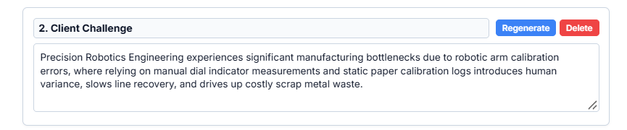

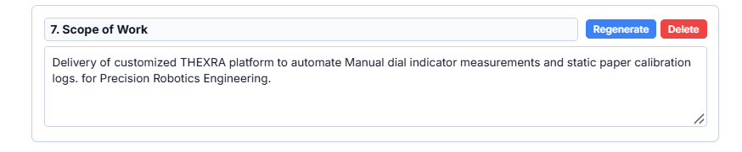

- Resolved Output (Prompt V2 Validation - Case 01: Precision Robotics):
- Observation: Re-testing Case 01 confirmed that Section 7 generates active execution verbs (“Turnkey engineering deployment, integration, and validation…”) and Section 2 generates a fluid 6-step user journey without quotes.
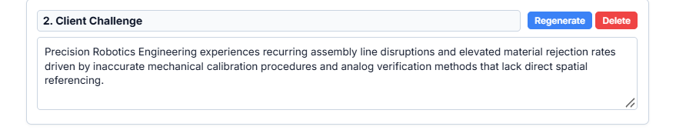
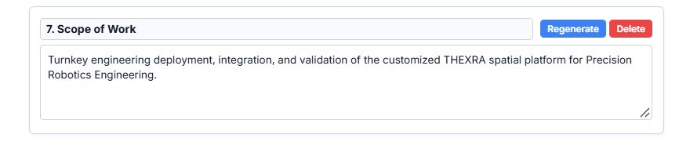

- Resolved Architecture & System Flow Diagram (Prompt V2 Validation - Case 01: Precision Robotics):
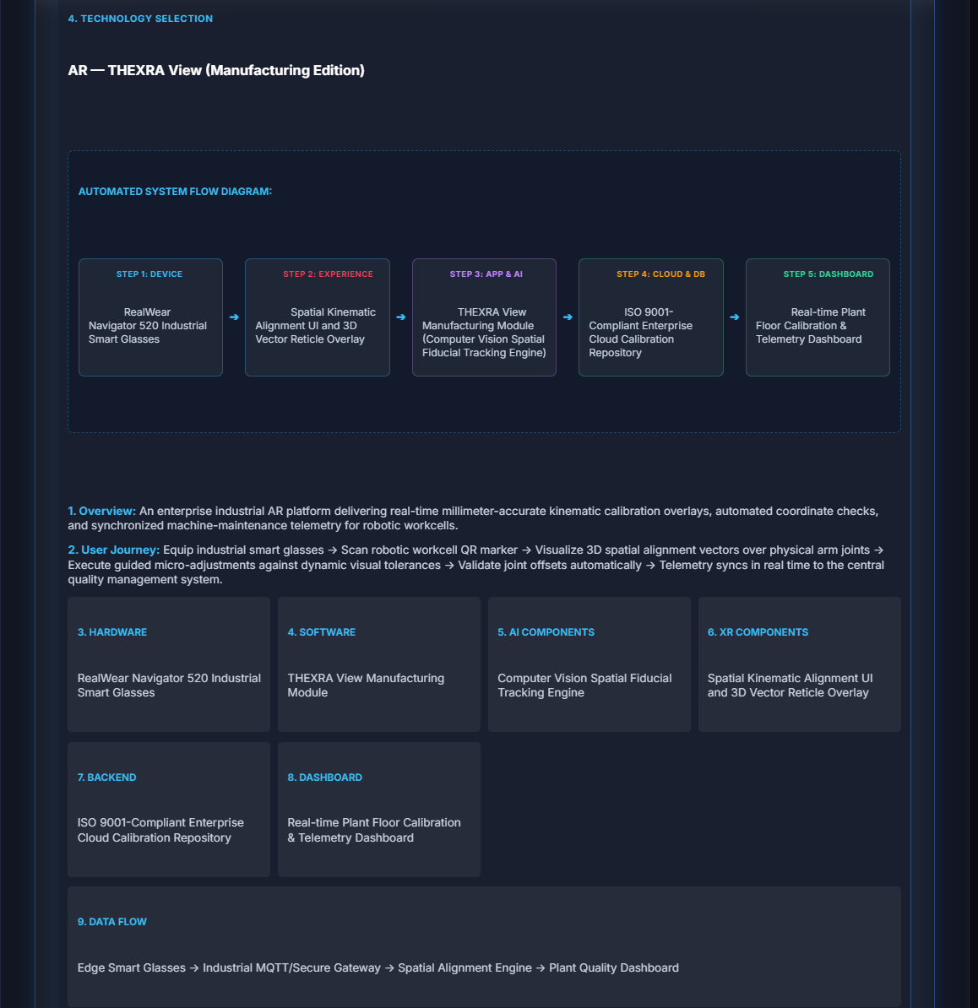

Deliverable: Updated Code (script.js)
- Main Proposal Generation (prompt):
const prompt = `Role: Expert Enterprise AI & Solution Architect for THEXRA.
Task: Analyze client intake data using grounded technology knowledge (${techContext}) and industry knowledge (${industryContext}). Be concise, clear, and direct.

CLIENT DATA:
Company Name: ${clientInfo.companyName}
Industry: ${clientInfo.industry}
Core Business Problem: ${clientInfo.problem}
Current Operational Process: ${clientInfo.currentProcess}
Target Users: ${clientInfo.targetPersona} (${clientInfo.targetUserCount} active users)
Desired Business Outcome: ${clientInfo.desiredOutcome}
Budget Range: ${clientInfo.budgetRange}
Target Timeline: ${clientInfo.timeline}

CRITICAL FORMAT, PARAPHRASING & GROUNDING RULES:
1. MANDATORY PARAPHRASING: Never copy raw intake text verbatim or wrap user problem strings in literal quotation marks. Rephrase all client challenges into executive-grade corporate prose.
2. "recommendedTechnology": Select the single technology category from ${industryContext} that directly solves ${clientInfo.problem}. Format: "[Category] — THEXRA [Product Name] (${clientInfo.industry} Edition)".
3. "userJourney": Construct a fluid, active operational workflow using action verbs. NEVER directly concatenate raw input strings into the template.
4. "scopeOfWork": Must strictly use action-oriented execution verbs (e.g., "Deploy, configure, integrate, test, and deliver..."). Do NOT restate the client problem description or use "automate [currentProcess]".
5. DYNAMIC INDUSTRY ADAPTATION: Tailor hardware, software modules, regulatory assumptions, and deliverables to ${clientInfo.industry}.
6. "implementationPlan": Exactly 7 sequential stages (Discovery, Design, Prototype, Development, Testing, Deployment, Support). Cumulative durations across stages 1 to 6 MUST strictly fit ${clientInfo.timeline}.
7. Return ONLY raw valid JSON matching this schema...`;

- Section Regeneration (sectionPrompt):
const sectionPrompt = `Role: Expert Enterprise Solution Architect for THEXRA.
Task: Write a single, highly detailed, professional paragraph for the proposal section titled "${sectionTitle}".

CLIENT CONTEXT:
- Company Name: ${company}
- Industry: ${industry}
- Core Business Problem: ${problem}
- Current Operational Process: ${process}
- Target Outcome: ${outcome}
- Existing Content: "${currentText}"

CRITICAL INSTRUCTIONS:
1. Write 2-3 concise, realistic sentences specifically tailored to "${sectionTitle}".
2. MANDATORY PARAPHRASING: Never copy raw input strings verbatim or wrap problem descriptions in literal quotation marks.
3. FOR "Scope of Work": Must strictly use action-oriented execution verbs (e.g., "Deploy, configure, integrate, test, and deliver..."). Do NOT restate client challenges or problem descriptions.
4. Do NOT use generic templates. Address ${company}'s specific situation directly.
5. Return raw plain text ONLY. Do NOT use markdown, JSON wrappers, or quotation marks.`;



